**Docker Assignment 3**

**You have been asked to:**

● Use the saved image in the previous assignment

● Upload this image on Dockerhub

● On a separate machine pull this dockerhub image, and launch it on port 80

● Start the apache2 service

● Verify if you are able to see the apache2 service

**A. Use the saved image in the previous assignment**

**Step 1: Go** to the **“EC2 Console”, rename** the **“assignment2” image** asthe **“visaltyagi12/assignment3”. Use** the **below-given** **command:** sudo docker tag assignment2 visaltyagi12/assignment3.

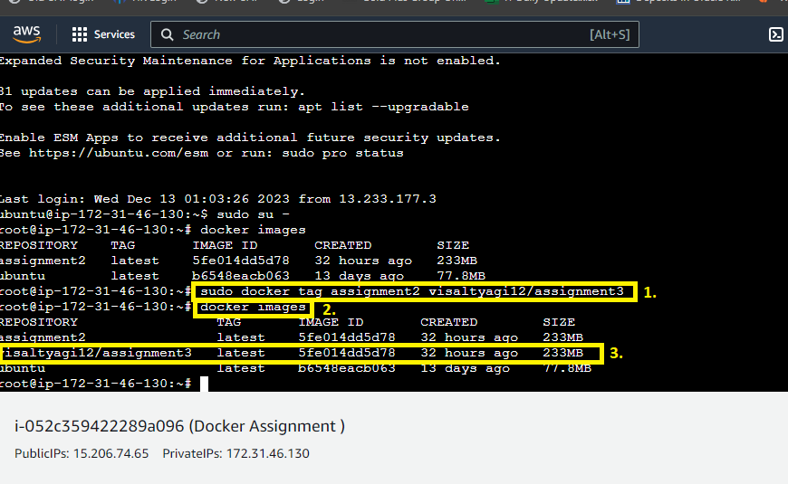

**When you do** the **“docker images”, a new repository** will be **created** as **“visaltyagi12/assignment3”.**

**B. Upload this image on Dockerhub**

**Step 1: Now, we** will **login** into our **DockerHub account** using this **command:** sudo docker login.

**Provide** the **“username and password”** here. **Login** will be **successful.**

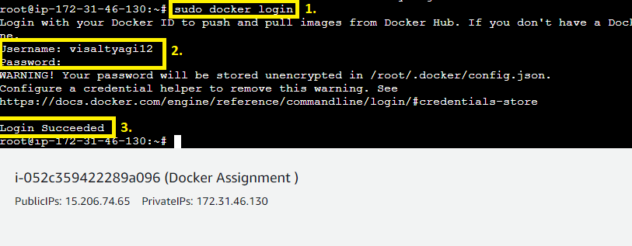

**Step 2: Use** this **command [sudo docker push visaltyagi12/assignment3]** to **push** the **image** into the **Docker Hub.**

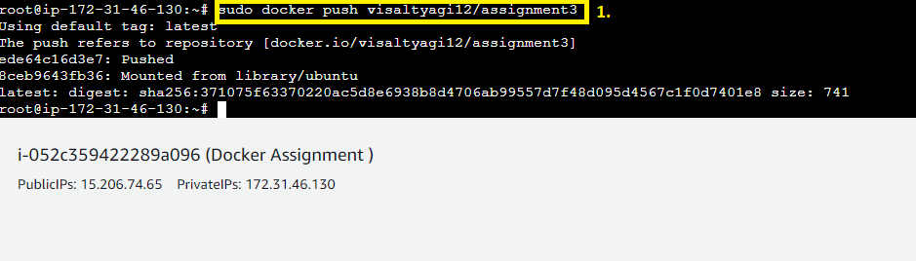

**Step 3: Login** into your **Docker Hub Account** & **The repository** will be **shown as “visaltyagi12/assignment3”.**

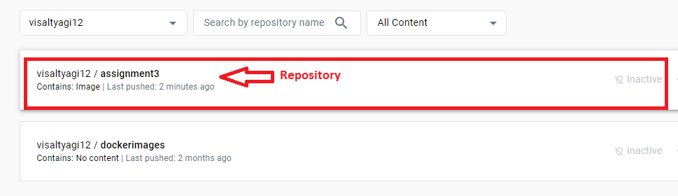

**Step 4: Click** onthe **“visaltyagi12/assignment3”. All** the **information inside** the **image** will be **shown.**

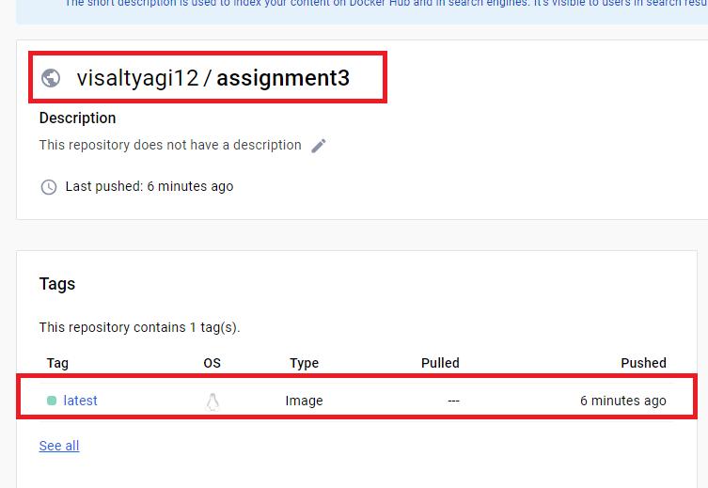

**C. On a separate machine pull this dockerhub image, and launch it on port 80**

**Step 1: Now, we** will **create** a **new instance** for **pulling** the **DockerHub image. We** have **created** a **new instance** as the **“Assignment3”, which** is **in** the **“Running State”.**

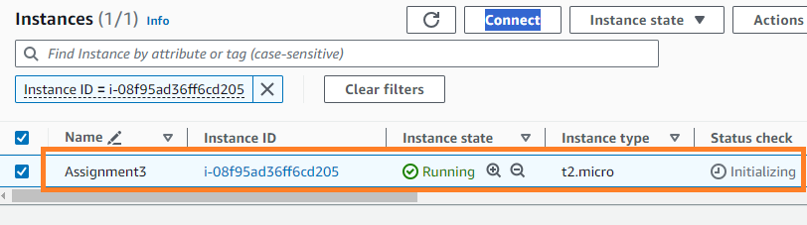

**Step 2: Connect** with the **“Assignment3 machine”.**

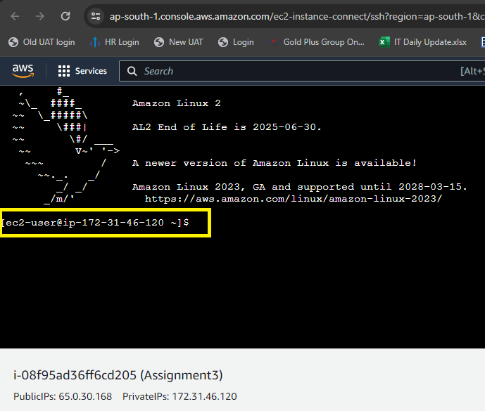

**Step 3: Now, we** have **installed** the **Docker & go inside** the **root user using** the **following commands:**

**sudo yum install docker –y to install docker.**

**sudo su – for root user.**

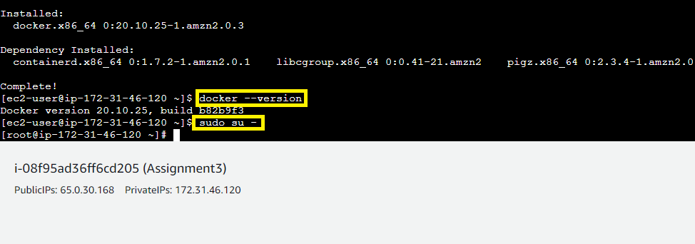

**Step 4: First, we** will **pull** the **image** fromthe **DockerHub. Use** this **command: sudo docker pull visaltyagi12/assignment3.**

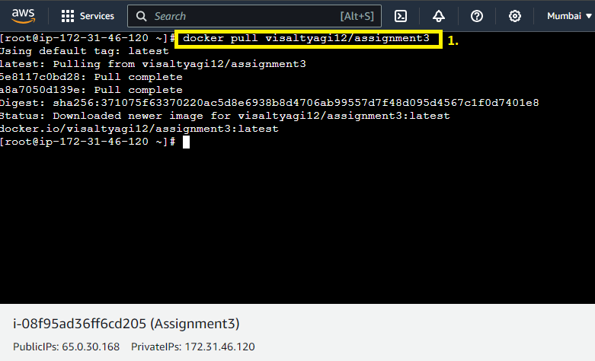

**Step 5: The Image** will be **shown using** the **command: docker images. The Image** will be **successfully pulled.**

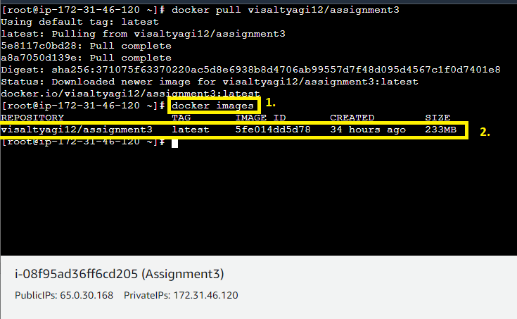

**Step 6: Now, we** will **create** a **container through** this **image** on the **port number 80. Use** this **command: “docker container run –itd –p 80:80 --name testcont visaltyagi12/assignment3”.**

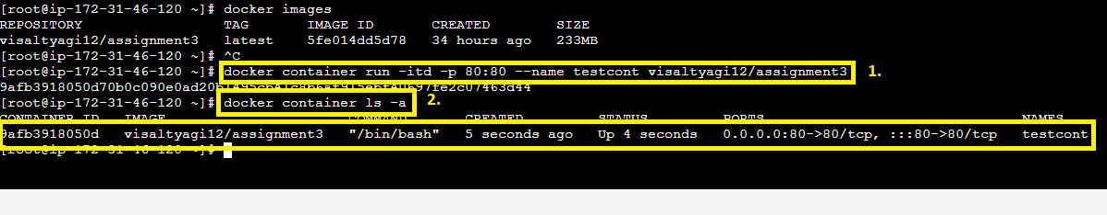

**When you do** the **“docker container ls –a”, you** will **notice** that **the container** is **successfully created** on the **port no. 80.**

**Step 7: Go inside** the **container using** this **command:**

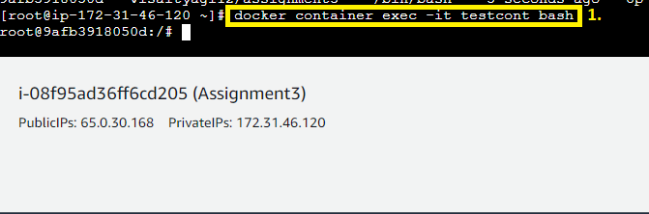

**Step 8: Run** the **“apt update’ command** to **update** the **machine. For installing** the **apache2** in the **container using** this **command: apt install apache2.**

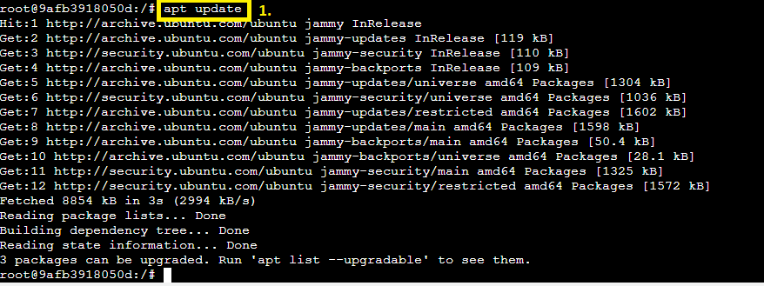

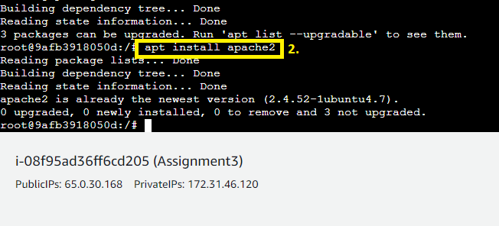

**D. Start the apache2 service**

**Step 1: Run** these **commands** to **check the status & start** the **apache2.**

**Command: “service apache2 start”** for **Starting Apache2.**

**Command: “service apache2 status”** for **Status Check**

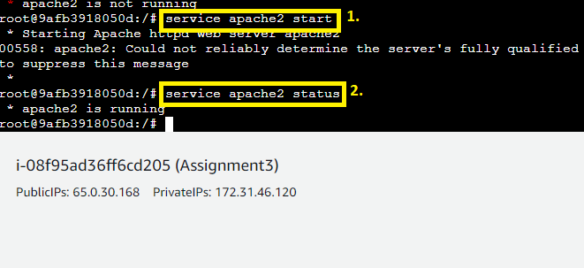

**E. Verify if you are able to see the apache2 service**

**Step 1: For verifying that,** the **Apache2** is **installed or not, go** to the **“EC2 Instance”** section**, select** the **“Running Instance”.**

**Click** onthe **“Open Address”** in the **“Public IPv4 Address”.**

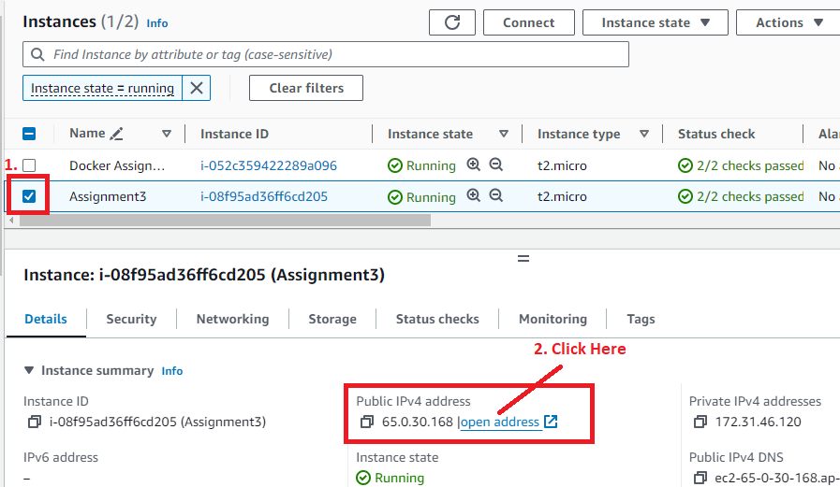

**Step 2: A separate web page** will be **opened** withthe **IP Address. It** will **show you** the **default Apache2 Web Page.**

